NOODLE RECIPE

- Mix the 2 cups of flour with the ½ teaspoon of salt in a mixing bowl.
- Beginning at the center of the mound, drizzle a small amount of cold water over the flour.
- Using your spoon gently stir in the water
- Gradually incorporate most, but not all of the water
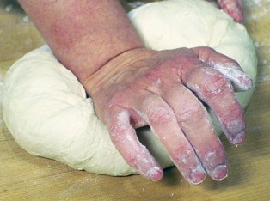
- Once most of the water is in and the flour is sticking together into a ball…
- Dust flour on the plastic covering on the table
- Place dough ball on the floured surface
- Knead the dough until smooth
- Let it rest a couple of minutes
- Again Dust a good amount of flour onto the table
- Roll the dough (it will be firm), using the rolling pin working from center out.
- It should be REALLY thin
- Cut strips using the pizza cutter
- Cut strips into small rectangles
- Place on Plastic plate and bring over to teacher.
- After cooking for about 5 minutes, you will get to top it with butter, cheese, and/or seasoning and eat.

